Support your child with their career choices – a parent’s guide
It is now well established that young people are required to remain in some form of education or training until the age of 18 – but this does not mean your child must stay at school after their GCSEs.
Research confirms that adolescents and young people, place a high value on the opinions and views of their parents or guardians when it comes to making critical careers choices.
As a parent, starting conversations as early as possible about career choices and discouraging your child to make last-minute decisions, are proven strategies to make sure your child is making a well-informed decision about their future.
We know, however, how difficult it can be for parents to support their child when it comes to critical career decisions. With a growing number of progression routes and weird and wonderful technical terms, it can sometimes be difficult for some parents to feel involved in the process.
Therefore, we have created this section on our website so you as parents or guardians can be as informed as possible to support your child when it comes to making career choices.
If you require any further assistance once you have had time to digest the information on the pages below, please do not hesitate to contact ……………………………………..via email:…………………………… or by telephone on ………………………………………………………. Thank you.
Additionally, if you feel that you could contribute to the Schools Career Programme by talking about your own career journey, would like to talk to our students about making a good application and stand out in a crowd, or feel you could give feedback on CVs and interview technique, please contact our Careers Leader …………………………………………………………..

It is always worth exploring different routes, even when your child has decided on their chosen job or career. Some jobs might require College, others might need College first then an apprenticeship, others might require a University Degree or you might be able to do an apprenticeship straight from school. The links on this page will help you with this.
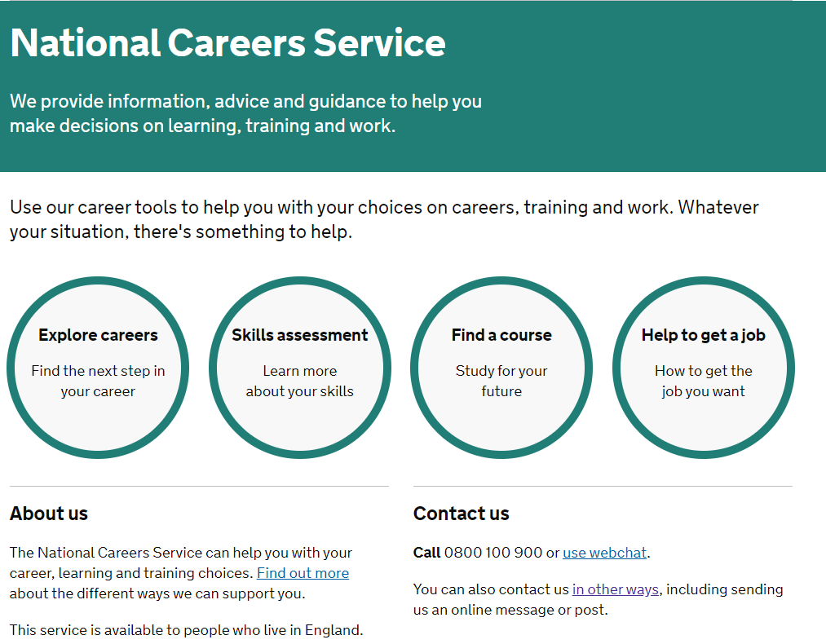
https://nationalcareers.service.gov.uk/ - The National Careers Service
The National Careers Service was established as by the government to allow everyone to access information about careers and finding a job. It offers impartial and extensive information about a range of careers and progression routes.
By clicking on the ‘Explore Careers’ button, you can type in the job you are looking for. It will then show you the qualifications and training required for that job. It will also summarise the general duties, skills required and salary for the job you are interested in.

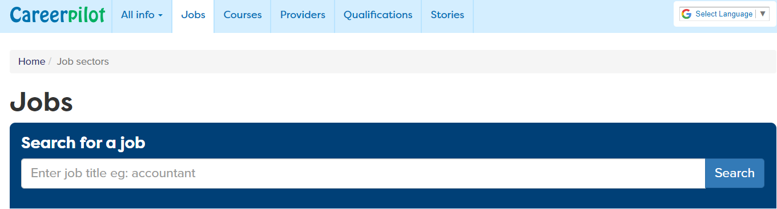

https://www.careerpilot.org.uk/job-sectors
The Careers pilot Page will allow you to search for specific jobs and give you information regarding: current employment trends, salary, working hours, duties and allow you to search for vacancies

I would like to find out more about my child’s choices after College and year 11

There are several useful websites which can help you explore your child’s choices after year 11. These choices include:
- Sixth form (where your child might the opportunity to study and/or A-levels or BTEC qualifications)

- College (where your child might have the opportunity to study vocational and technical qualifications in a wide range of both practical and academic areas)

- T Level Qualifications

- Apprenticeships

- Traineeships


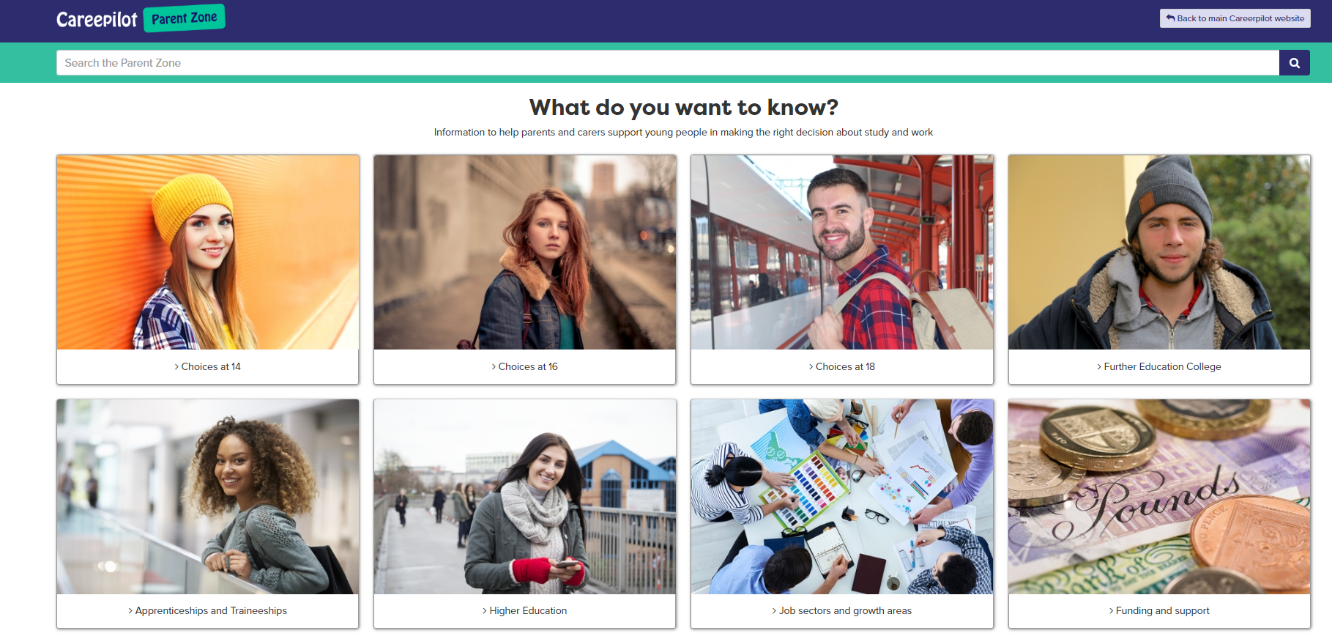

https://careerpilot.org.uk/parent-zone - The Parent Zone by Career Pilot
On the Career Pilot page, you can find out information regarding jobs, college courses, apprenticeship and higher education options. It is a good starting point to find out general information about possible progression routes.
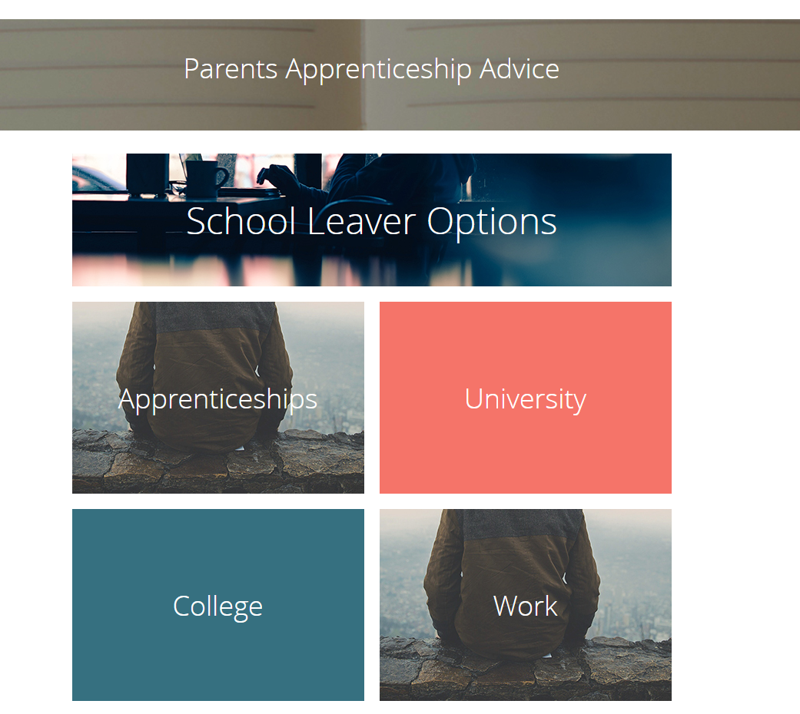

https://www.allaboutschoolleavers.co.uk/parents - The All About School Leavers website
On this page, you can find information on all the options your child has after year 11 or after their College course. On their website you can search for jobs and apprenticeships and explore different industries to find out more about possible future jobs or progression routes.

https://www.apprenticeships.gov.uk/ National Apprenticeship website
If you would like to find out specific information about apprenticeships, including case studies, information about different types of apprenticeships and to search for vacancies both nationally and locally, from intermediate to degree level apprenticeships, this website will be extremely useful.
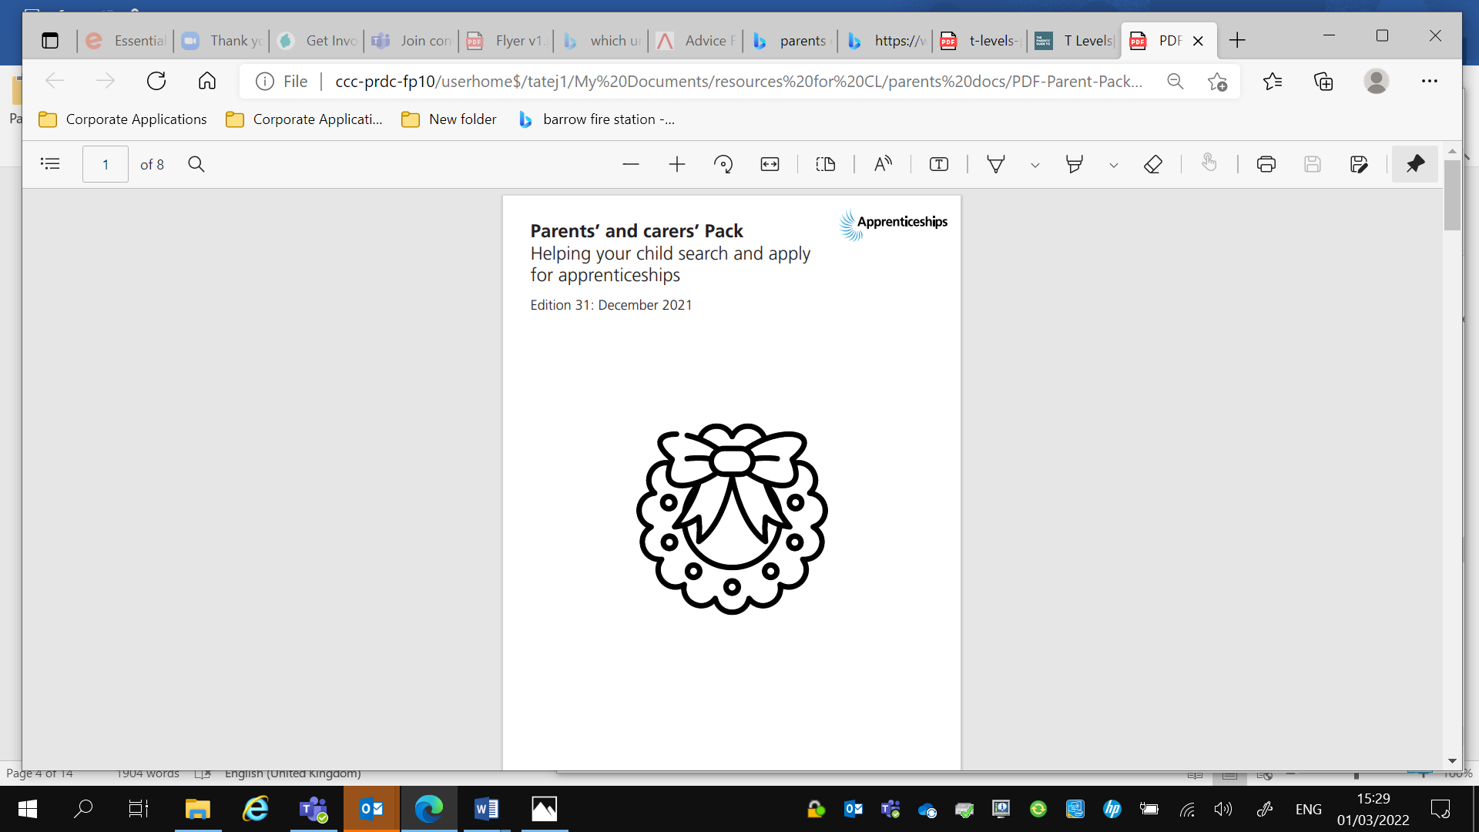
t-levels-parent-guide.pdf PDF-Parent-Pack-December-2021.pdf

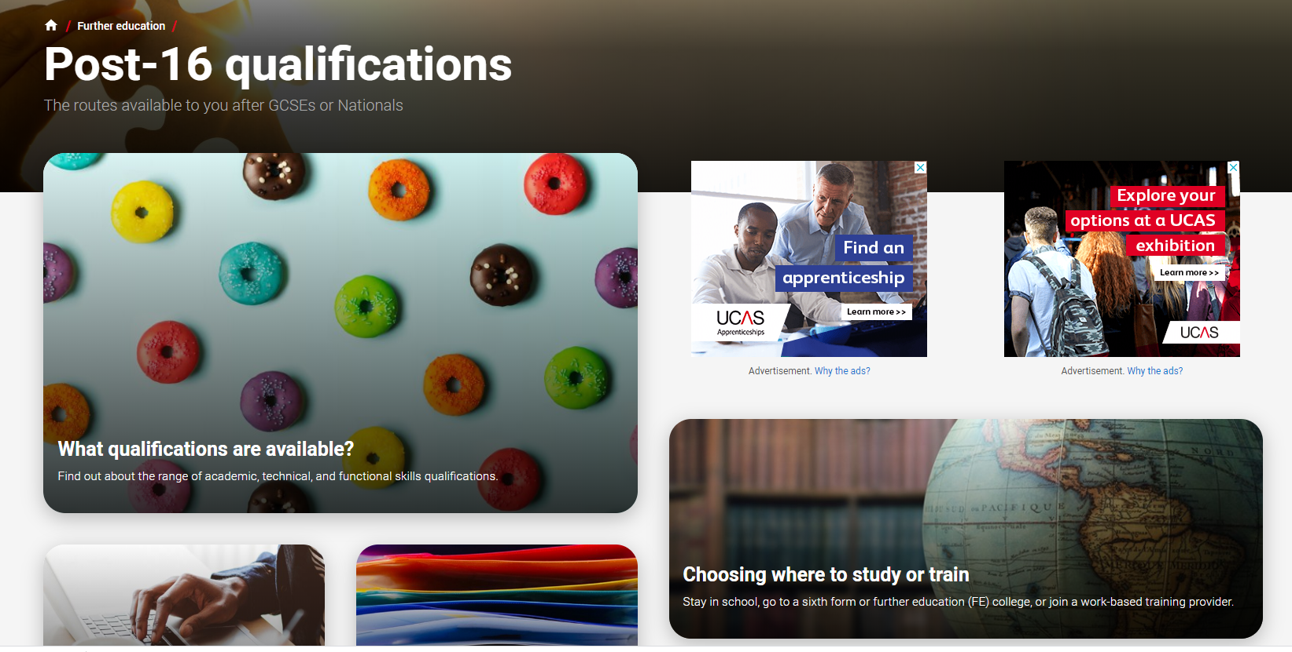
https://www.ucas.com/further-education/post-16-qualifications - UCAS Post - 16 options
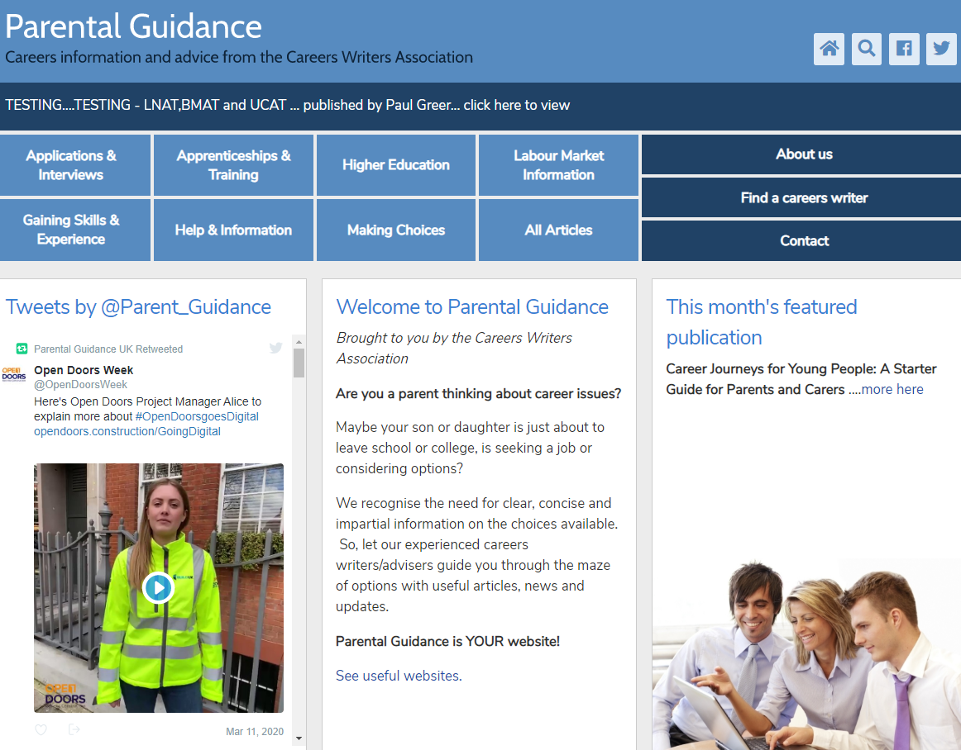
The UCAS page has useful information on thee main page about the choices after school or college and explains things clearly. Through other links on their website you can also search for apprenticeship vacancies and find out how to apply for University.

https://www.parentalguidance.org.uk/ Parental Guidance website
The PG website is a great starting point to find out about lots of basic information about your child’s progression options, from explaining the different levels of apprenticeships to being able to get advice and tips about interviews.



http://www.push.co.uk
The Push website has lots of useful information about your future options, it is particularly useful if you would alternatives to University.

My child has no idea what they would like to do in the future

It can be difficult to strike up a conversation with your child about their career ideas when they keep saying ‘’I don’t know what I want to do.’’ In this situation it can be useful to look at all options and attend as many open evenings or taster sessions as possible or arrange some work experience so that your child can experience a particular job first-hand.

Luckily, there are also some websites which might help in this situation.



https://launchyourcareer.com/ Launch Your Career
On the Launch Your Career webpage there is a very useful and fun quiz that your child could take. After the quiz it will help you to identify your skills and interests and match them to a range of jobs or careers. The quiz is free to use and will link you with an animal. I was a Sea Horse!


https://www.careersbox.co.uk/ - Career Box
To help you explore future progression routes, Career Box will allow you to access lots of videos and case studies about a range of jobs and training routes.

University Applications
For some parents or guardians, the University process can feel scary and an unknown, even for parents or guardians who have been through the process before, it can also be an unknown as things change and develop. You child will receive support through the College throughout the application process, but in the meantime, there are a number of useful sources of information for you to access.

UCAS, the organisation your child will apply through, put together a free to download guide for parents and guardians. It can be accessed here Advice For Parents And Guardians | UCAS | Parent Guide To University

www.thecompleteuniversityguide.co.uk – Th Complete University Guide
This is an excellent website for general information in all areas of the University application process. You can find out about open days, search for courses and find out about fee or careers.

https://www.push.co.uk/
The UCAS page on the Push website will give you a good overview of the process, but it also has lots of good tips and advice about student finance, picking accommodation and budgeting.
https://digital.ucas.com/search - UCAS Course Search
This an excellent starting point to search for courses across the UK. It will allow you to search for courses you might be aware of and courses you didn’t know you existed. It will allow you to research entry requirements and universities who offer the course you are interested in.


www.whatuni.com – WhatUni
The WhatUni website contains lots of useful information for all aspects of the University application process. On their main page you will find a course search tool which will show you all the courses in the country who offer your course. It will also show you employment rates, drop out rates and entry requirements for each course.
I would like to know how to write a personal statement
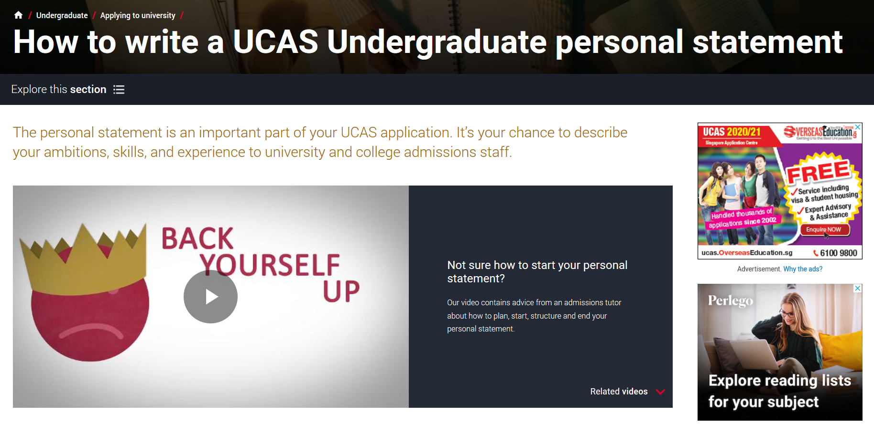
https://www.ucas.com/undergraduate/applying-university/how-write-ucas-undergraduate-personal-statement - UCAS - Personal Statement
UCAS have some excellent writing frames, advice and videos which should take the uncertainty and ‘scary’ side of writing your personal statement.
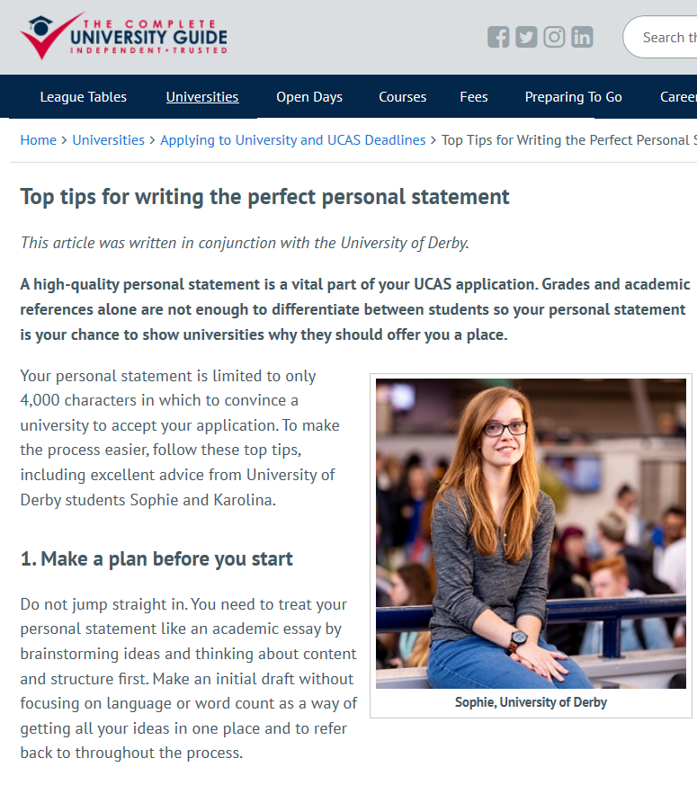

https://www.thecompleteuniversityguide.co.uk/universities/applying-to-university-and-ucas-deadlines/top-tips-for-writing-the-perfect-personal-statement - The Complete University Guide

The Complete University Guide’s Person Statement page gives some great top tips about writing a great personal statement. After visiting the UCAS page, this would be a useful page to read over.
I would like to search for open days and taster days

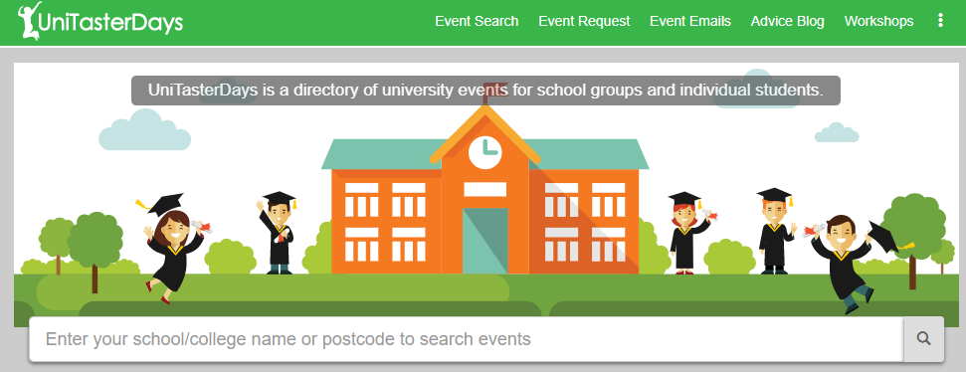

www.unitasterdays.com
Unitasterdays.com is a great site to search for taster days and open days. You can book through the website and search for upcoming events.



Opendays.com is a excellent site to search for all upcoming open days so you can plan your trips in advance see what’s happening soon.

I would like to know how the Student Finance system works
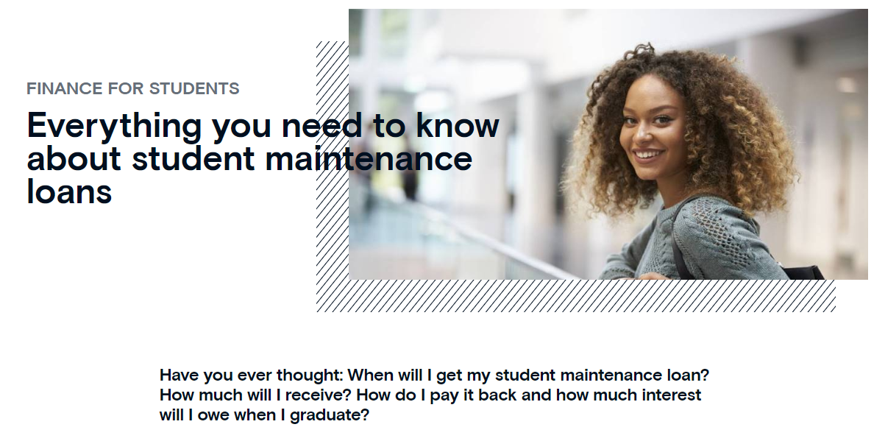
https://www.futurefinance.com/blog/what-you-need-to-know-about-student-maintenance-loan/
This website gives excellent information about the main loan students receive – the Maintenance Loan. It explains how to apply, how much you might be entitled to and how it is repaid.
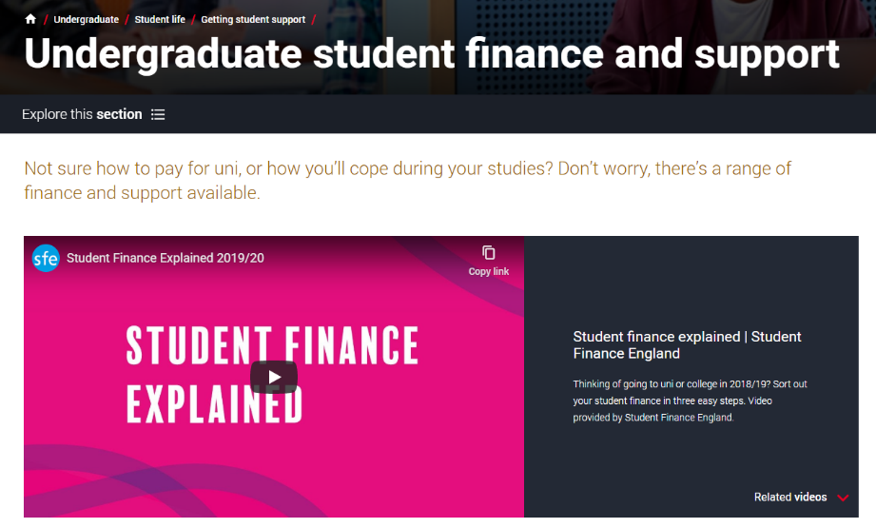

https://www.ucas.com/undergraduate/student-life/getting-student-support/undergraduate-student-finance-and-support -- UCAS Student Finance
For a general overview of the Student Finance System, UCAS have some really information videos and information.
I would like to explore current labour market trends and the ‘Jobs of Tomorrow’

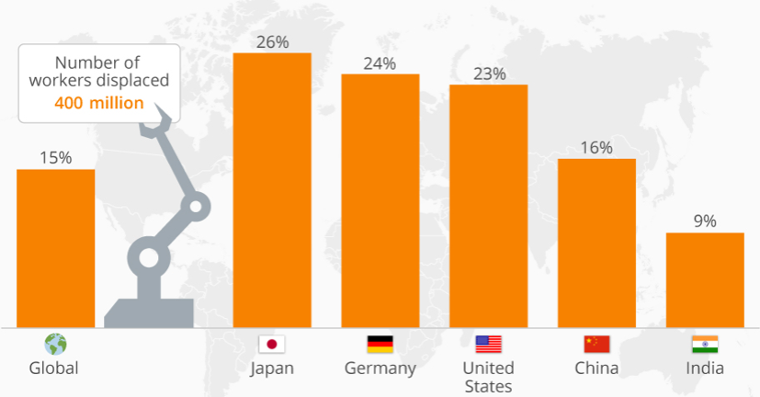
We now have access to what is called Labour Market Information (LMI). LMI can be national or local, but will show you trends in terms of job growth or decline in certain industries or areas of the country.
This information can be useful when discussing future careers or jobs with your child. The links below can be used to find both national and local information and can be used to find job specific data.
It can sometimes be difficult to find job specific data for Cumbria, so please read the information carefully.

I want to find out labour market information specific to a job

https://guest.startprofile.com/
Using SrartProfile, on their webpage in the search box at the top of the page type in the job you would like information on. You can then search for LMI by clicking on ‘Availability’ on the left-hand side. This information is more national than local.


https://www.careerpilot.org.uk/job-sectors
On the ‘Jobs’ tab on the Careers pilot Page, you will be able to find specific job LMI by searching for the job you are interested in. Similar to the StartProfile page – this is job specific and not regional data.

https://launchyourcareer.com/
Once you have completed the quiz on the main page, you can search for specific jobs which will then show you if that job is going to grow and decline in the coming years. Again, the information is based on national figures, but it is still a good start point.

I want to search for Cumbria Specific Data

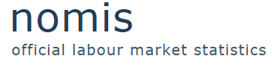
https://www.nomisweb.co.uk/reports/lmp/la/1941962771/report.aspx?town=cumbria
Nomis collects employment data in each area of the country. If you would an overview of employment rates and county specific sectors, this is a useful website.


https://assets.publishing.service.gov.uk/government/uploads/system/uploads/attachment_data/file/483122/LMI_Summary_-_Cumbria__Final_.pdf
For a general overview of the job market and growth sectors in Cumbria, this report is very useful.


https://www.cumbriaobservatory.org.uk/economy-employment/economy-employment-further-information/
For LMI specific to Cumbria and all the regions within Cumbria, if you follow this link, then click on Current Cumbria Observatory Briefings, Summaries & Resources then Labour Market Briefing you will find information regarding the biggest employers in the area, skills employers are looking for and growth sectors in the local area.

I want to explore Jobs of Tomorrow

I

https://www.careerconnect.org.uk/Jobs-For-Tomorrow-i109.html
The Careers Connect outline their research on which sectors might grow in the future. A useful starting point when exploring future jobs or career paths.


https://www.monster.co.uk/career-advice/article/top-ten-in-demand-jobs-for-the-future
Monster have completed research into what they think will the biggest 10 jobs growing or will be in demand within the next 10 years.

